מגישים:

ניצן בר-אל: 322450552

עילי כץ: 212321871

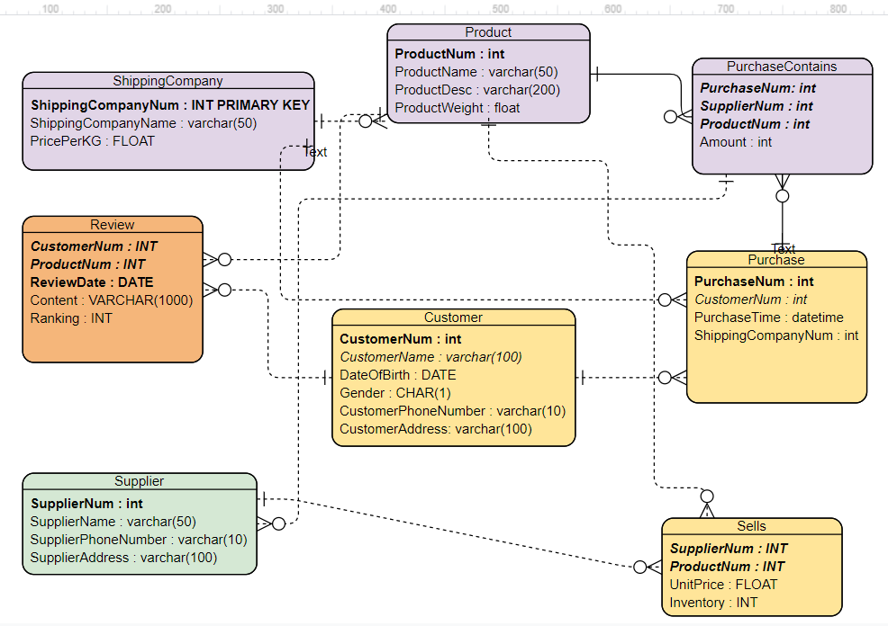

הנחנו שהקשרים באחד לרבים הם:

1. חברת משלוחים למוצרים.
2. חברת משלוחים לרכישות.
3. מוצר לביקורות.
4. מוצר למכירות.
5. מוצר ל רכישה מכילה.
6. לקוח לביקורות.
7. לקוח לרכישות.
8. רכישה ל רכישה מכילה.
9. ספק למכירות.

a.

CREATE TABLE Review(CustomerNumINT, ProductNumINT, ReviewDateDATE, ContentVARCHAR(1000),Ranking INT, PRIMARY KEY (CustomerNum, ProductNum,ReviewDate), FOREIGN KEY (CustomerNum) REFERENCES Customer(CustomerNum), FOREIGN KEY (ProductNum) REFERENCES Product(ProductNum) );

b.

.mode csv

.importReviewTableData.csv Review;

c.

SELECT ProductNum, UnitPrice, Inventory FROM Sells WHERE SupplierNum = 154;

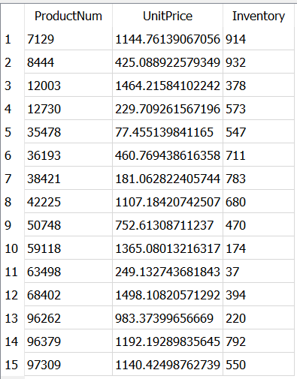

d.

SELECT PurchaseNum, PurchaseTime FROM Purchase INNER JOIN Customer ON Purchase.CustomerNum = Customer.CustomerNum WHERE Customer.CustomerName= "Jerry Morris";

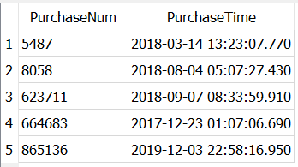

e.

SELECT avg(Ranking) FROM Review INNER JOIN Product ON Product.ProductNum = Review.ProductNum WHERE Product.ProductName = "Emrobor";

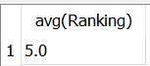

f.

SELECT ShippingCompany.ShippingCompanyName,ShippingCompany.ShippingCompanyNum, count(Purchase.ShippingCompanyNum) FROM ShippingCompany LEFT OUTER JOIN Purchase ON Purchase.ShippingCompanyNum = ShippingCompany.ShippingCompanyNum GROUP BY ShippingCompany.ShippingCompanyNum ORDER BY count(\*) DESC;

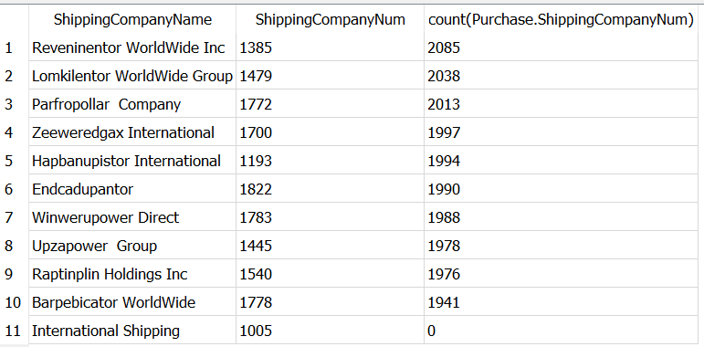

g.

SELECT sum(calA), sum(calP) FROM(SELECT sum(x.Amount) as calA, x.Amount\*UnitPrice as calP FROM (SELECT \* FROM PurchaseContains WHERE PurchaseContains.PurchaseNum = 225) as x INNER JOIN Sells ON Sells.ProductNum = x.ProductNum AND Sells.SupplierNum = x.SupplierNum GROUP BY calP);

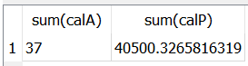

h.

SELECT Customer.CustomerNum, Customer.CustomerName, Customer.DateOfBirth, Customer.Gender, Customer.CustomerAddress, Customer.CustomerPhoneNumber FROM Customer INNER JOIN (SELECT DISTINCT Purchase.PurchaseNum, Purchase.CustomerNum FROM Purchase INNER JOIN PurchaseContains ON Purchase.PurchaseNum = PurchaseContains.PurchaseNum WHERE Purchase.PurchaseTime like '2018%' AND PurchaseContains.ProductNum <>4402) as x ON Customer.CustomerNum = x.CustomerNum GROUP BY x.CustomerNum HAVING count(\*) >= 5;

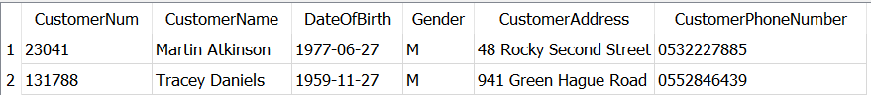

i.

The statement return the ProductNum and the number of customers who ordered it in the year of 2019 and have been ordered at least by 40 different customers this year